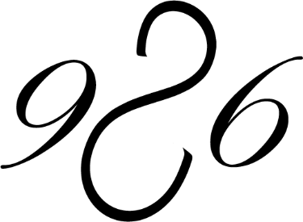

- COVID-19 Liability Release Waiver
**Signature Required Prior to Every Scheduled Appointment**
- Due to the 2019-2020 outbreak of the novel Coronavirus (COVID-19), Salon 926 is taking extra precautions with the care of every client to include health history review and enhanced sanitation/disinfection procedures in accordance with the Michigan LARA Regulations.
Symptoms of COVID-19 include:
  - Fever
  - Fatique
  - Dry Cough
  - Difficulty Breathing
- I agree to the following:
I understand the above symptoms and affirm that I, as well as all household members, do not currently have, nor have experienced the symptoms listed above WITHIN THE LAST 14 DAYS. I affirm that I, as well as all household members, have not been diagnosed with COVID-19 WITHIN THE PAST 30 DAYS. I affirm that I, as well as all household members, have not knowingly been exposed to anyone diagnosed with COVID-19 WITHIN THE PAST 30 DAYS. I affirm that I, as well as all household members, have not traveled outside of the country, or to any city considered to be a "hot spot" for COVID-19 infections WITHIN THE PAST 30 DAYS. I understand that Salon 926 cannot be held liable for any exposure to the COVID-19 virus caused by misinformation on this form or the health history provided by each client. I understand that I am required to wear a mask upon entering the salon, and required to wear the mask during the time I am at Salon 926. If I refuse to wear a mask, I will be asked to leave and there will be a full charge for the cost of my appointment. If I am unable to wear a mask due to a health condition, I will be required to reschedule an appointment during high risk times. I understand that there is a 24-hour cancellation notice required on my reservation. There is a 100% charge if I do not reschedule or cancel my reservation within 24 hours.
- Salon 926 is following these enhanced procedures to prevent the spread of COVID-19. Things are changing rapidly and we will do our best to update you on our website: Additional time included between appointments to prevent client contact with each other.
Guests accompanying those scheduled for services is no longer offered
We will abide to 25% occupancy at all times, and are offering an area for parents to come with their children that is isolated from the salon area
Each client is required to wear a mask
Each client required to sanitize hands upon arrival and before leaving
Your service provider will thoroughly clean hands and wear a mask during all treatments.
Your service provider will wear a clean mask at all times and an apron.
All product bottles used during treatment will be placed on the trolley for disinfection and disposable items will be used when possible
All surfaces will be wiped thoroughly with hospital grade disinfectant before and after each client according to the manufacturer's directions
There is no waiting area available, so clients are asked to wait in their vehicle until the salon texts to enter
No beverages or magazines will be offered during your visit.
Bathroom use will be for emergency use only.
By signing below, I agree to each statement above and release Salon 926 from any and all liability for the unintentional exposure or harm due to COVID-19.
Salon 926 agrees to abide by these standards and affirms the same.

- Date
- Name

- Email

- Phone Number

- Signature

